**Project Design Phase-II**

**Technology Stack (Architecture & Stack)**

|  |  |
| --- | --- |
| Date | 24 June 2025 |
| Team ID | LTVIP2025TMID29498 |
| Project Name | Asset Management Portal |
| Mentor Name | Dr Shaik Salma Begum |
| Maximum Marks | 4 Marks |

**Technical Architecture:**

The Deliverable shall include the architectural diagram as below and the information as per the table1 & table 2

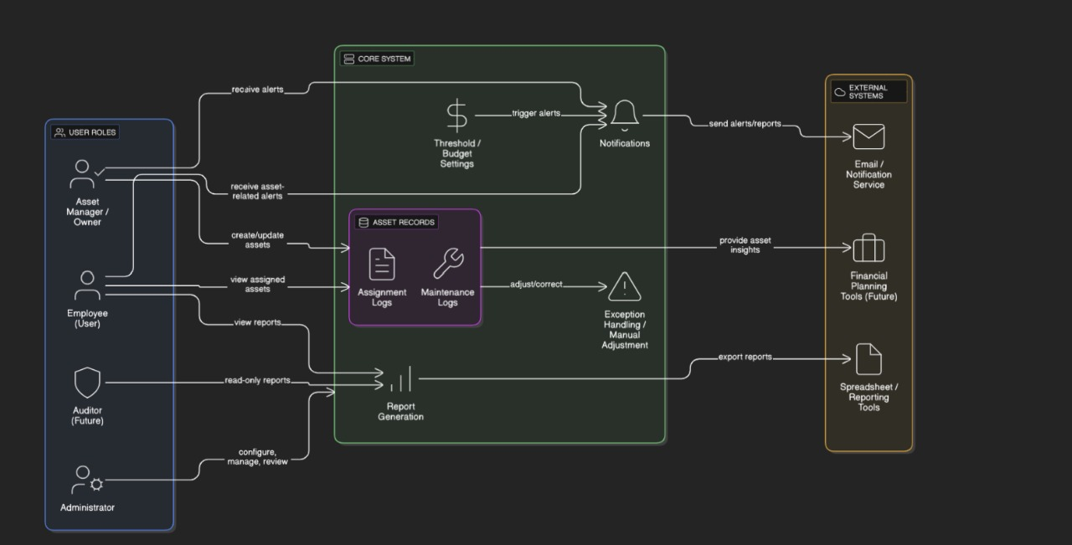

**Table-1 : Components & Technologies:**

| **S.No** | **Component** | **Description** | **Technology** |
| --- | --- | --- | --- |
| 1. | **User Interface** | Web-based forms and dashboards for asset tracking and management | ServiceNow UI Framework (Form Designer, Lists, Service Portal) |
| 2. | **Application Logic – 1** | Dynamic form behavior, field visibility, validation rules | ServiceNow Client Scripts, UI Policies (JavaScript, GlideForm API) |
| 3. | **Application Logic – 2** | Automation of asset lifecycle events like assignment, updates, and disposal | ServiceNow Flow Designer / Workflow Engine |
| 4. | **Application Logic – 3** | Alerts and email notifications for maintenance, audits, or disposal schedules | ServiceNow Notification Engine |
| 5. | **Database** | Stores asset records, users, departments, conditions, and history | ServiceNow Custom Tables (Assets, Users, Requests, Logs), MySQL Backend |
| 6. | **External API – 1** | Integration with procurement, maintenance systems, or audit tools | ServiceNow REST API |
| 7. | **Infrastructure (Cloud)** | Hosted on cloud platform with secure, scalable, and compliant environment | ServiceNow SaaS Cloud Infrastructure |

**Table-2: Application Characteristics:**

| **S.No** | **Characteristic** | **Description** | **Technology** |
| --- | --- | --- | --- |
| 1. | Open-Source Frameworks | Uses JavaScript for form logic; can extend with AngularJS or React for advanced customization | JavaScript, AngularJS (optional), ReactJS (optional) |
| 2. | Security Implementations | Role-based access (Admin, Asset Manager, Employee), secure endpoints | ServiceNow ACLs, HTTPS, TLS, Role-based IAM |
| 3. | Scalable Architecture | Cloud-based, modular design; supports expanding asset types, rules, or workflows | ServiceNow Cloud Platform, REST APIs |
| 4. | Availability | High uptime ensured via ServiceNow’s redundant and fault-tolerant infrastructure | ServiceNow SaaS with HA infrastructure |
| 5. | Performance | Optimized record processing and caching, load-balanced delivery of static/dynamic resources | ServiceNow Caching, Akamai CDN or equivalent |